MOBILE APPLICATION

FOR

AQUAPONICS SALES

**Submitted by:**

Edoo Jameel Mohammad Ibraheem

Yogheswar Surjoo

Vibahakarsingh Beeharry

Hachim Hasssan Bacc

**MODULE NAME: GENIE LOGICIEL**

**Université des Mascareignes**

**Faculty of ICT**

**FEBRUARY 2024**

Table of Contents

**1** **| INTRODUCTION** 3

**1.1** **INTRODUCTION** 3

**1.2** **PROBLEM STATEMENT** 4

**1.3** **AIMS AND OBJECTIVES** 5

**2** **| SYSTEM DEVELOPMENT** 6

**2.1** **UML ANALYSIS AND MODELLING** 6

**2.1.1** **Definition of Actors** 6

**2.1.2** **Definition of Use Cases** 7

**2.1.3** **Use Case Diagram** 8

**2.1.4** **Detailed Description of Use Cases** 9

# **1 | INTRODUCTION**

# **INTRODUCTION**

Mauritius has seen a significant increase in the amount of small aquaponics farmers in recent years. Aquaponics, a sustainable bio-farming method that sees the combination of aquaculture and hydroponics, has piqued the interest of many Mauritians seeking to adopt a better eating lifestyle.

Studies have shown that Mauritius is one of the leading countries in Africa when it comes to the use of pesticides and fertilizers in the agricultural industry.

Aquaponics is often the go to solution for many people in regards to bio-farming, the reason being that it offers a holistic approach to agriculture through the combination of aquaculture and hydroponics to create a self-sustainable system which does not rely on external sources such as chemical fertilizers to stimulate plant growth.

# **1.2 PROBLEM STATEMENT**

First of all, amateur aquaponics practitioner face many challenges when it comes setting up and running an aquaponics system. One of the difficulties many of them face is that they may not be able to provide a constant supply of products to resellers due to their small-scale production. As such, they are obliged to find buyers from the general public on their own to sell their products to.

This can be a troubling task as the only available options are paid advertising which is expensive and non-profitable, and social media advertising which can be a tedious task for many, assuming they have the time to engage in it.

On the other hand, the number of people who are opting for a healthier dietary choice has increased over the years due to concerns of high pesticide usage in in the agricultural industry in Mauritius. And one of the main obstacles for members of the general public in that regards, is the difficulty in locating merchants who sell organic products in their neighborhood.

Not to mention that in most cases, verifying whether these products are in fact organic and well cultivated is not possible for buyers to confirm on their own without the help of a third party organization.

# **1.3 AIMS AND OBJECTIVES**

The primary objective of this project is to create a mobile application with the purpose of establishing a connection between amateur or small-scale aquaponics practitioners across Mauritius and members of the general public who are looking for sellers of organic products in their vicinity.

The mobile application will be affiliated with an organization dedicated in the promotion and education of either aquaponics or organic farming in general in Mauritius. The main reason for this, is because this organization will have the responsibility of allowing only merchants who are selling organic aquaponics products to gain access to the application’s merchant side.

In regards to the problems faced by small aquaponics merchants in Mauritius, by way of establishing a connection between the merchants and buyers interested in their products, be it small-scale producers or amateurs, aquaponics practitioners will no longer have to worry about finding clients on their own.

When it comes to members of the public, finding merchants who are selling certified organic products, specifically aquaponics products, will prove to be much easier.

The mobile application will allow merchants to display their products along with their location. Members of the public will then be able to locate the closest merchants to them or find merchants by searching for products or specific locations directly.

# **2 | SYSTEM DEVELOPMENT**

# **2.1 UML ANALYSIS AND MODELLING**

The system development phase will begin with an analysis of the requirements of the system to accomplish defined tasks within the system.

This will be accomplished using the principles of Unified Modelling Language (UML); more specifically, we will define the actors and use cases within the system along with UML diagrams to provide a visual representation.

# **2.1.1 Definition of Actors**

“Actors can be defined as something that interacts with the system. The actors can be human user, some internal applications or may be some external applications.” (Waykar, 2015)

Actors within the system can be divided into two categories, namely, primary actors and secondary actors.

**Primary Actors**

An actor who requires the development of one or more functionalities within the system to be able to accomplish their defined tasks is referred to as a primary actor.

The mobile application constitutes only of the following primary actors:

* Aquaponics Merchants
* Clients
* System Administrators

# **2.1.2 Definition of Use Cases**

The definition of a use case in light of this project is a written description of a specific task or action which will be performed by the primary actors of the system within the mobile application.

* The list of use cases to be performed by the pre-registered aquaponics merchants:

1. Type of User Selection (Seller or Buyer) – Select Seller

2. User Authentication Only (Sign In)

3. Input their contact info, address and location within the app

4. Input their products & related information

5. Receive & approve orders placed by clients along with notifications

6. Receive/Send direct messages from clients via the app

* The list of use cases of clients from the general public:

1. Mode Selection (Seller or Buyer) – Select Buyer

2. User Registration (Sign Up)

3. User Authentication (Sign In)

4. Input their contact info, address and location within the app

5. Viewing available aquaponics merchants close to them

6. Searching for merchants based on specific products & a specified location or town

7. Place Orders from merchants – specify amount, delivery/pickup, payment mode (Cash/Juice)

8. Send/Receive direct messages to merchants

* The list of use cases for System Administrators:

1. User Authentication (Admin Login)

2. Merchant/Seller registration

# **2.1.3 Use Case Diagram**

The purpose of a use case diagram is to produce a visual representation of the operational mechanism of the web application and its use cases in relation to the actors of the system.

This diagram facilitates the development process since the developer can clearly see the interactions between the different parts of the system.

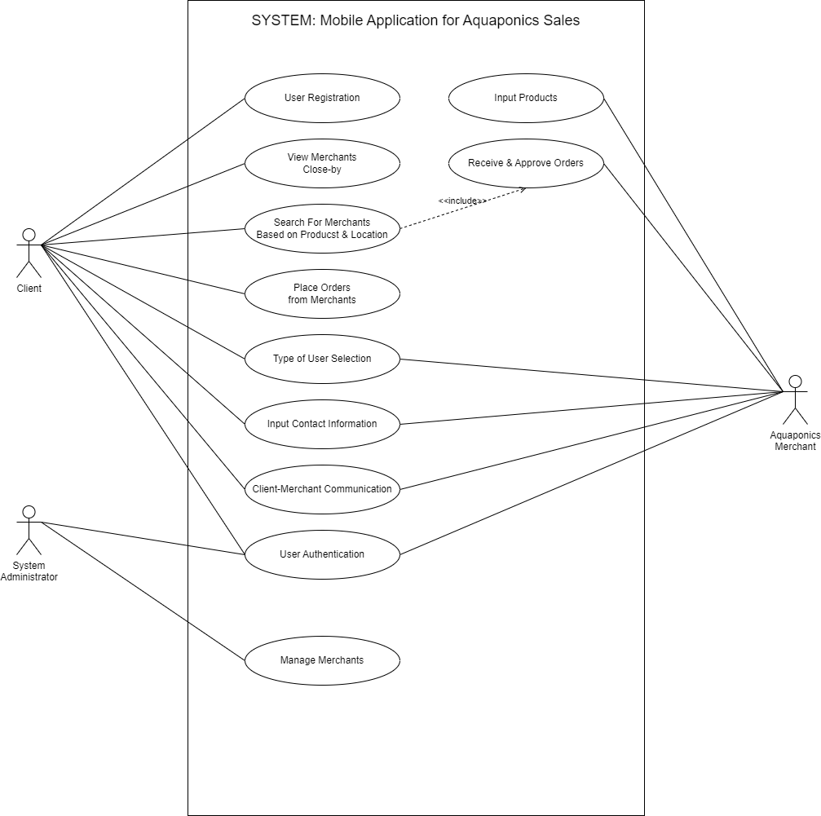

**Figure 1: Use Case Diagram**

# **2.1.4 Detailed Description of Use Cases**

1. Client

|  |
| --- |
| Case n°1 |
| **Use Case Name:** Place Order  **Actor:** Client  **Description** : Client browses, selects products, checks out, and confirms order.   * **Pre-conditions** : * Client is registered and logged into the system. * Merchant has an active account with products listed. * Client has chosen desired products from the merchant's listing. |

**Basic Flow:**

1. **Browse Products:**

* The client browses the merchant's product listing, searching by category, name, or using other available filters.
* The system displays product details, including images, descriptions, prices, and available quantities.

1. **Select Products:**

* The client selects the desired product(s) by clicking on "Add to Cart" buttons.
* The system adds the chosen product(s) to the client's virtual shopping cart, potentially displaying a confirmation message and updating the cart total.

1. **Review Cart:**

* The client accesses the shopping cart to review the selected items, quantities, and total cost.
* The system displays a summary of all products in the cart, including options to edit quantities or remove items.

1. **Choose Delivery/Pickup:**

* The client selects their preferred delivery method (e.g., home delivery, in-store pickup) if applicable.
* The system may display associated delivery fees or estimated delivery times based on the chosen method.

1. **Enter Payment Information:**

* The client enters their payment information securely (e.g., credit card details).
* The system employs secure payment processing to capture and verify the information.

1. **Place Order:**

* The client confirms the order details and clicks a "Place Order" button.
* The system transmits the order information to the merchant, including product details, delivery preferences, and client contact information.

1. **Order Confirmation:**

* The system displays a confirmation message to the client, including order details and an estimated delivery timeline.

**Alternative Flows:**

* **Insufficient product quantity:** The system informs the client and allows them to adjust the quantity or choose alternative options.
* **Payment processing failure:** The client is notified and given the option to retry payment or choose a different payment method.
* **Order cancellation:** The client can choose to cancel the order before the merchant confirms it. The system allows the client to remove items from the cart or cancel the entire order.

**Post-conditions:**

* An order is placed with the merchant.
* The client receives confirmation and order details.
* The merchant receives notification and order details.

|  |
| --- |
| Case n°2 |
| **Use Case Name:** User registration  **Actor:** Client  **Description** : Client browses, selects products, checks out, and confirms order.   * **Pre-conditions** : User is new to the system and has not previously registered. |

**Basic Flow:**

1. **Access Registration Page:** The user accesses the registration page through the system's interface, often labeled "Sign Up" or "Create Account".
2. **Provide Personal Details:** The user enters their personal information, typically including:
   * **Required:**
     + Name
     + Email address
   * **Optional:**
     + Phone number
     + Address
     + Birthday
3. **Create Login Credentials:** The user sets a username and password for future logins. The system may enforce password complexity requirements.
4. **Agree to Terms and Conditions:** The user reviews and agrees to the system's terms of service and privacy policy.
5. **Submit Registration:** The user clicks a "Submit" or "Register" button to send the information to the system.
6. **Verification (optional):** Depending on the system, the user might need to verify their email address through a link sent to their inbox.

**Alternative Flows:**

* **Missing required information:** The system prompts the user to enter any missing mandatory details.
* **Invalid email address:** The system informs the user of the error and allows them to correct the email address.
* **Weak password:** The system enforces password complexity rules and prompts the user to create a stronger password.
* **Terms and conditions not accepted:** The user cannot complete registration without agreeing to the terms and conditions.

**Post-conditions:**

* Upon successful registration, the user receives a confirmation message and is either:
  + Logged in automatically.
  + Directed to a login page to use their newly created credentials.
* The user's information is stored securely in the system's database.

|  |
| --- |
| Case n°3 |
| **Use Case Name:** View Merchants Close-By  **Actor:** Client  **Description** : Client browses, selects products, checks out, and confirms order.  **Pre-conditions** :   * Client is registered and logged into the system. * Location services are enabled on the client's device (optional). |

**Basic Flow:**

1. **Request Location (optional):**

* If location services are enabled, the system retrieves the client's current location (latitude and longitude).
* Alternatively, the client can manually enter their desired location (e.g., zip code, city name).

1. **Search for Merchants:**

* The system uses the client's location (either retrieved or provided) to search for merchants within a specified radius (e.g., 5km).

1. **Display Results:**

* The system displays a list of nearby merchants, including:
  + - Merchant names and addresses.
    - Distance from the client's location.
    - Category or product type (optional).
    - Ratings and reviews (optional).

1. **View Merchant Details (optional):**

* The client can click on a specific merchant from the list to view detailed information, such as:
  + - Full address and contact information.
    - Operating hours.
    - Additional product details or images.

**Alternative Flows:**

* **Location services disabled:** The system prompts the client to enable location services or allows them to manually enter their location.
* **No merchants found:** Informs the client that no merchants are currently available within the specified radius.

**Post-conditions:**

* The client has access to a list of nearby merchants based on their location.
* They can choose to view individual merchants for further details.

**Additional Considerations:**

* This is a simplified example, and the actual use case might involve additional functionalities like filtering based on specific categories or sorting by distance.
* The use case diagram would also need to consider the actors involved (e.g., merchants updating their location information).

|  |
| --- |
| Case n°4 |
| **Use Case Name:** Search for Merchants based on Products & Location  **Actor:** Client  **Description** : Client searches products and location, system finds nearby stores.   * **Pre-conditions** : Client is registered and logged into the system. |

**Basic Flow:**

1. **Enter Search Criteria:**

* The client interacts with the search interface, potentially including:
  + - Entering keywords or selecting product categories.
    - Specifying a location (e.g., zip code, city name) or using their current location (optional).
    - Applying additional filters (optional), such as price range, ratings, or specific features.

1. **Submit Search:**
   * The client clicks a "Search" or "Find" button to submit their search criteria.
2. **Process Search Query:**

* The system searches the database based on the provided criteria:
  + - Matching product names, descriptions, or categories.
    - Filtering by location (if provided) or using the client's current location (if enabled).
    - Applying any additional filters selected by the client.

1. **Display Search Results:**

* The system displays a list of merchants that meet the search criteria, including:
  + - Merchant names and addresses.
    - Product information or images (relevant to the search query).
    - Distance from the client's location (if applicable).
    - Additional details like ratings or reviews (optional).

1. **Refine Search (optional):**

* The client can further refine their search by:
  + - Modifying search keywords or filters.
    - Adjusting the location radius (if applicable).
* The system updates the results based on the revised criteria.

**Alternative Flows:**

* **No results found:** The system informs the client that no merchants currently meet their search criteria and offers suggestions to broaden their search.
* **Location services disabled:** The system prompts the client to enable location services for more accurate results.

**Post-conditions:**

* The client has access to a list of merchants based on their search criteria.
* They can choose to view individual merchants for further details.
* They can refine their search further to narrow down the results.

|  |
| --- |
| Case n°5 |
| **Use Case Name:** Client-Merchant Communication  **Actor -Client:** Initiates communication with the merchant.  **Description** : Client browses, selects products, checks out, and confirms order.  **Pre-conditions** :   * Both client and merchant are registered and logged into the system. * The client has identified a specific merchant they want to communicate with. |

**Basic Flow:**

1. **Client Initiates Communication:**

* The client accesses a dedicated communication channel within the system for the chosen merchant. This could involve:
  + - Sending a direct message.
    - Initiating a chat conversation.
    - Using a built-in messaging system within the platform.

1. **Client Sends Message:**

* The client composes their message, potentially including:
  + - Inquiries about products or services.
    - Order-related questions or requests.
    - General communication regarding their needs.

1. **System Sends Message:**

* The system securely transmits the client's message to the merchant through the designated communication channel.

1. **Merchant Receives Message:**

* The merchant receives a notification about the new message from the client.

1. **Merchant Reviews Message:**

* The merchant reviews the message content and understands the client's request.

1. **Merchant Sends Response:**

* The merchant composes a response to the client's message, potentially including:
  + - Answers to inquiries.
    - Updates on order status or other relevant information.
    - Proposals or clarifications regarding the client's needs.

1. **System Sends Response:**

* The system securely transmits the merchant's response back to the client.

1. **Client Receives Response:**

* The client receives a notification and can access the merchant's response through the designated communication channel.

**Alternative Flows:**

* **Merchant unavailable:** If the merchant is offline or unavailable at the time, the client may be notified and offered options to leave a message or try again later.
* **Technical issues:** In case of system errors or technical issues, both client and merchant might receive error messages or experience delays in communication.

**Post-conditions:**

* Client and merchant have established communication through the system's designated channels.
* They can continue exchanging messages to address inquiries, resolve issues, or facilitate transactions.

|  |
| --- |
| Case n°6 |
| **Use Case Name:** User Authentication  **Actor:** User (Client or Merchant)  **Description** : User enters credentials, system verifies and grants access or denies.  **Pre-conditions** : User is on the login page of the system. |

**Basic Flow:**

1. **Enter Credentials:**

* The user enters their login credentials, typically:
  + - Username or email address
    - Password

1. **Submit Login:**

* The user clicks a "Login" or "Sign In" button to submit their credentials.

1. **System Authenticates:**

* The system verifies the user's credentials against its database, checking:
  + - Username/email exists
    - Password matches the user's account

**Alternative Flows:**

1. **Invalid Credentials:**

* If the username or password is incorrect, the system:
  + - Displays an error message informing the user of invalid credentials.
    - Offers options to retry login or reset password.

1. **Account Locked (optional):**

* If the user enters incorrect credentials multiple times, the system might:
  + - Lock the account temporarily for security reasons.
    - Require additional verification (e.g., security questions) to unlock.

**Post-conditions:**

1. **Successful Login:**

* If authentication is successful, the system:
  + - Grants the user access to their account dashboard.
    - Sets a session cookie or token for further secure access within the system.

1. **Unsuccessful Login:**

* If authentication fails due to invalid credentials or account lock, the user remains on the login page and needs to address the issue before proceeding.

**Additional Considerations:**

* This use case assumes a single-factor authentication mechanism. Multi-factor authentication (MFA) might be implemented as an additional step, requiring further details in the diagram.
* The use case could be further extended to include functionalities like password reset, account recovery, and session management (e.g., logout, session timeout).

1. **System Administration**

|  |
| --- |
| Case n°7 |
| **Use Case Name:** Manage Merchants (Admin)  **Actor:** System Administration  **Description:** User enters credentials, system verifies and grants access or denies.   * **Pre-conditions:** Administrator is logged in to the system. |

1. **Access Merchant Management:**

* The administrator navigates to a dedicated section within the system for managing merchants.

1. **View Merchant List:**

* The system displays a list of all registered merchants, potentially including:
  + - Merchant names.
    - Account statuses (active, pending, suspended).
    - Additional details (optional, e.g., category, location).

1. **Select Merchant:**

* The administrator chooses a specific merchant from the list to manage their account.

1. **Manage Merchant Details:**

* Based on the selected merchant, the system allows the administrator to perform various actions, potentially including:
  + - **View/Edit Merchant Information:** Access and modify contact details, business information, and other relevant data associated with the merchant's account.
    - **Approve/Reject Registration:** Review and decide on pending merchant registration requests based on specific criteria.
    - **Suspend/Activate Account:** Manage the active status of the merchant's account.
    - **View Performance Data (optional):** Access data related to the merchant's performance within the system (e.g., transaction history, customer reviews).

**Post-conditions:**

* The administrator has performed desired actions to manage the selected merchant's account.
* The system reflects the updated information or changes made by the administrator.

**Alternative Flows:**

* **Merchant not found:** Informs the administrator if the selected merchant doesn't exist or cannot be located.
* **Insufficient permissions:** If the administrator attempts actions beyond their designated permissions, the system prompts them with an access denied message.

1. **Aquaponics Merchants**

|  |
| --- |
| Case n°8 |
| **Use Case Name:** Input Product  **Actor:** Aquaponics Merchant  **Description:** User enters credentials, system verifies and grants access or denies.  **Pre-conditions:**   * Aquaponics merchant is registered and logged in to the system. * Merchant has an active account with the system. |

**Basic Flow:**

1. **Access Product Input Interface:**

* The merchant navigates to a dedicated section within the system for adding or managing their products.

1. **Create New Product:**

* The system provides an interface for the merchant to enter new product details, potentially including:
  + - Product name and description.
    - Category selection (e.g., fish, plants, equipment).
    - Images or multimedia displaying the product (optional).
    - Price and availability information.
    - Stock level or inventory management options (optional).

1. **Submit Product Information:**

* The merchant reviews and submits the entered product details.

1. **System Processes Information:**

* The system validates the provided information and stores it in its database.

1. **Product Added (Optional Confirmation):**

* The system confirms successful product addition and displays the newly added product information.

**Alternative Flows:**

* **Missing required information:** The system prompts the merchant to enter any missing mandatory details.
* **Invalid information:** The system informs the merchant of any invalid data (e.g., incorrect pricing format) and allows them to correct it.
* **Image upload error (optional):** If image upload fails due to technical issues, the system informs the merchant and allows them to retry or continue without images.

**Post-conditions:**

* The Aquaponics merchant has successfully added a new product to their listings within the system.
* The product information is available for potential clients to view and browse.

**Additional Considerations:**

* This is a simplified example, and the actual use case might involve additional functionalities like:
  + Editing existing product information.
  + Managing product variations or options (e.g., different sizes, colors).
  + Setting up product promotions or discounts.
* The use case diagram could be further extended to show interactions with the system regarding managing product orders or responding to customer inquiries.

|  |
| --- |
| Case n°9 |
| **Use Case Name:** Receive and Approve Orders  **Actor:** Aquaponics Merchant  **Description:** User enters credentials, system verifies and grants access or denies.  **Pre-conditions:**   * Aquaponics merchant is registered and logged in to the system. * Merchant has an active account with product listings. |

**Basic Flow:**

1. **Access Order Management:**

* The merchant navigates to a dedicated section within the system for managing orders.

1. **View Orders:**

* The system displays a list of orders placed by clients, potentially including:
  + - Order details (product names, quantities, prices).
    - Customer information (name, contact details).
    - Order status (pending, awaiting approval, processing, completed).

1. **Select Order:**

* The merchant chooses a specific order to review and process.

1. **Review Order Details:**

* The system displays detailed information about the selected order, including:
  + - Ordered products and quantities.
    - Customer information and delivery preferences.
    - Total order amount and any applicable fees.

1. **Approve Order (optional):**

* If necessary, the merchant approves the order, indicating they can fulfill it based on availability and stock.
* This step might be automatic depending on system functionalities.

1. **Process Order:**

* The merchant initiates the process to fulfill the order, potentially involving:
  + - Confirming product availability.
    - Initiating packaging or preparing the order for delivery/pickup.
    - Communicating with the client regarding any updates or estimated delivery timeline (optional).

1. **Update Order Status:**

* The merchant updates the order status within the system to reflect the progress, such as "processing" or "shipped."

1. **(Optional) Mark Order as Complete:**

* Once the order is fulfilled and delivered/picked up by the client, the merchant can mark it as "completed" within the system.

**Alternative Flows:**

* **Order cancellation request:** The client might request to cancel the order before it is shipped. The merchant can choose to accept the cancellation and update the order status accordingly.
* **Insufficient stock:** If the merchant discovers insufficient stock to fulfill the order, they can:
  + Contact the client to discuss options (e.g., partial order fulfillment, alternative products).
  + Cancel the order and inform the client.
* **Technical issues:** In case of system errors, the merchant might experience difficulty updating order status or accessing order details.

**Post-conditions:**

* The Aquaponics merchant has reviewed, processed, and updated the status of an order placed by a client.
* The system reflects the updated order status and potential communication with the client (optional).

**Additional Considerations:**

* This is a simplified example, and the actual use case might involve additional functionalities like:
  + Managing order returns or refunds.
  + Tracking shipments and providing delivery updates to clients.
  + Communicating with clients regarding order-related issues or questions.